**Bandırma Onyedi Eylül University**

**Faculty of Art Design and Architecture**

**Scopus 2024 report**

1. 9 ORCIDs belonging to our faculty members were collected.
2. The publications in Scopus were checked by the instructors and the Head of the Department as stated in the Scopus report creation guide.
3. Using ORCIDs in Scopus, the following data were obtained using the relevant search criteria in Scopus.
4. 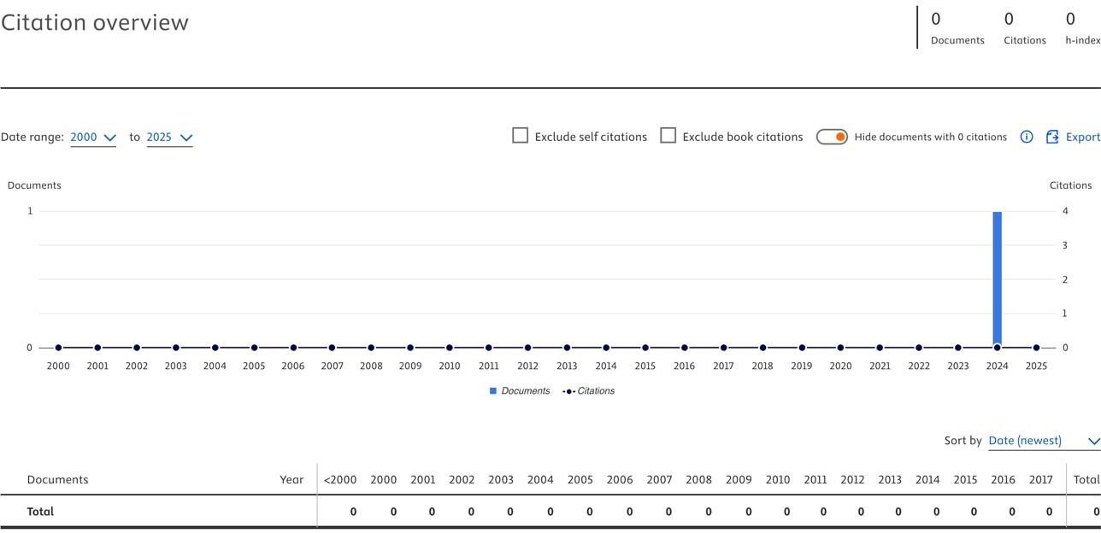In our department, 1 SSCI/SCI/SCI expanded article belonging to our academic staff for the year 2024 has been published and Bandırma Onyedi Eylül addressed publications have received 0 citations.
5. The table below shows the countries with which faculty members conducted their studies addressed to Bandırma Onyedi Eylül University.

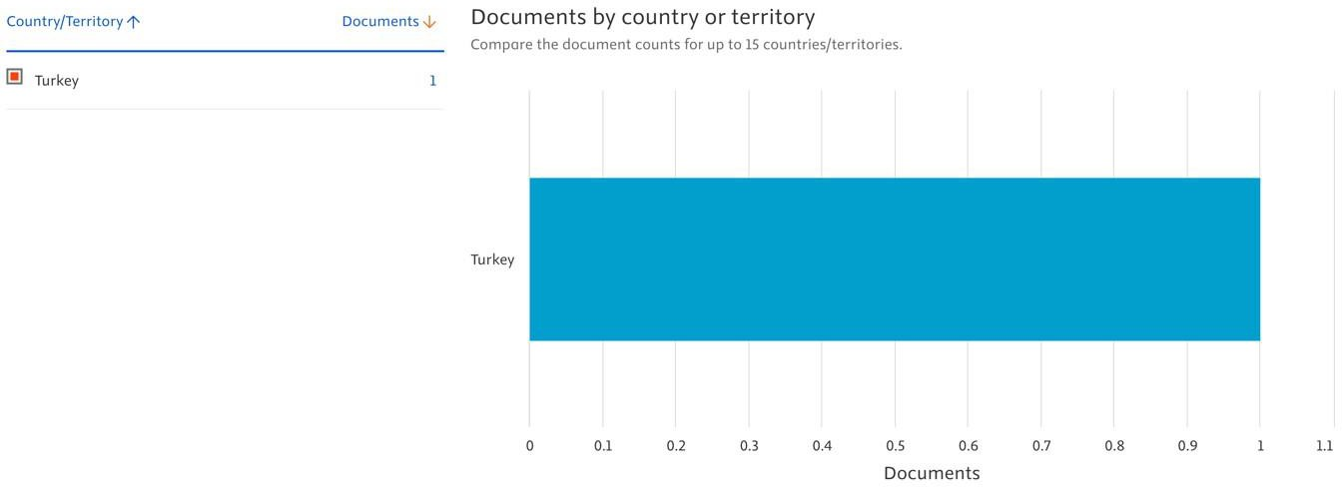

1. The table below shows with which universities the academic staff conducted their studies addressed to Bandırma Onyedi Eylül University.

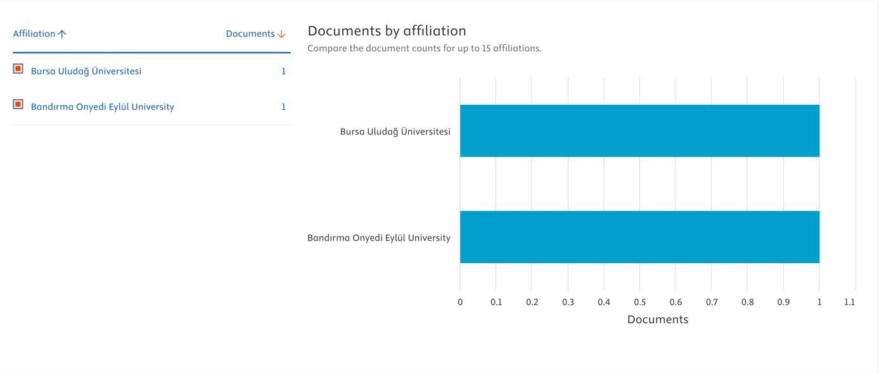

1. The table below shows the subjects on which faculty members conduct their studies addressed to Bandırma Onyedi Eylül University.

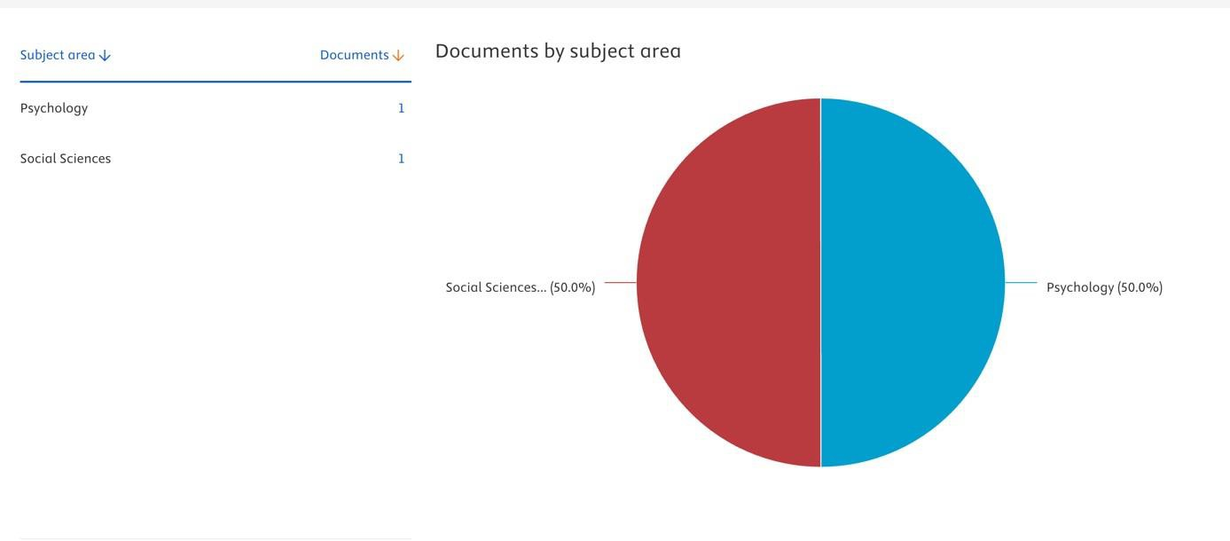

**Bandırma Onyedi Eylül University**

**Faculty of Art Design and Architecture**

**Tr Index 2024 report**

1. 9 ORCIDs belonging to our faculty members were collected in our department.
2. As stated in the TR Index Report Creation Guide, the publications in the TR index were checked by the lecturers and the Head of the Department.
3. Using ORCIDs in the TR index, the following data were obtained using the relevant search criteria in the TR index.
4. In our department, 3 TR indexed articles were published in 2024, 3 in 2023, 2021, 2014 and 1 in 2013, and there are 7 TR indexed articles in total.

**Bandırma Onyedi Eylül University**

**Faculty of Art Design and Architecture**

**WOS 2024 report**

1. 9 WOS Researcher IDs belonging to our faculty members were collected.
2. As stated in the WOS report creation guide, the publications in WOS were checked by the lecturers and the Department Head.
3. The following data were obtained using WOS Researcher IDs and the relevant search criteria in WOS.
4. 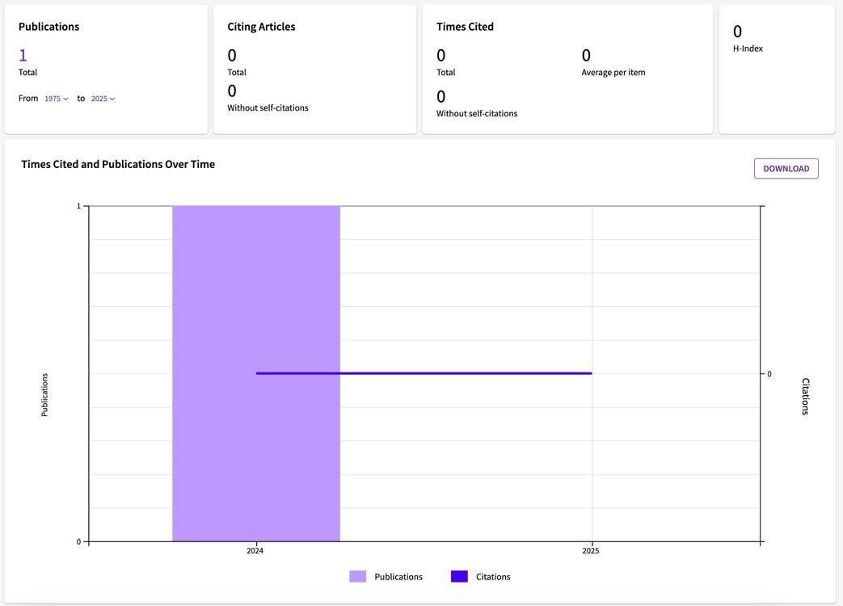In our department, 1 SCI / SCI expanded article was published by our academic staff in 2024 and 0 citations were received for publications addressed to Bandırma Onyedi Eylül.
5. The table below shows with which countries the academic staff conducted their studies addressed to Bandırma Onyedi Eylül University.
6. 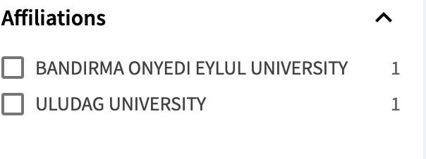The table below shows with which universities the academic staff conducted their studies addressed to Bandırma Onyedi Eylül University.
7. The table below shows the web of science category in which academic staff members conducted their studies addressed to Bandırma Onyedi Eylül University.
8.  The table shows which sustainable development goals are covered by the studies of the academic staff with the address of Bandırma Onyedi Eylül University.